REST ASSURED with status code and body

Adding these below content

**package** files;

**public** **class** bodycontent {

**public** **static** String addbody()

{

**return** "{\r\n" +

" \"location\": {\r\n" +

" \"lat\": -38.383494,\r\n" +

" \"lng\": 33.427362\r\n" +

" },\r\n" +

" \"accuracy\": 50,\r\n" +

" \"name\": \"Srikanth Bandi\",\r\n" +

" \"phone_number\": \"(+91) 983 893 3937\",\r\n" +

" \"address\": \"29, side layout, cohen 09\",\r\n" +

" \"types\": [\r\n" +

" \"shoe park\",\r\n" +

" \"shop\"\r\n" +

" ],\r\n" +

" \"website\": \"http://google.com\",\r\n" +

" \"language\": \"French-IN\"\r\n" +

"}";

}

}

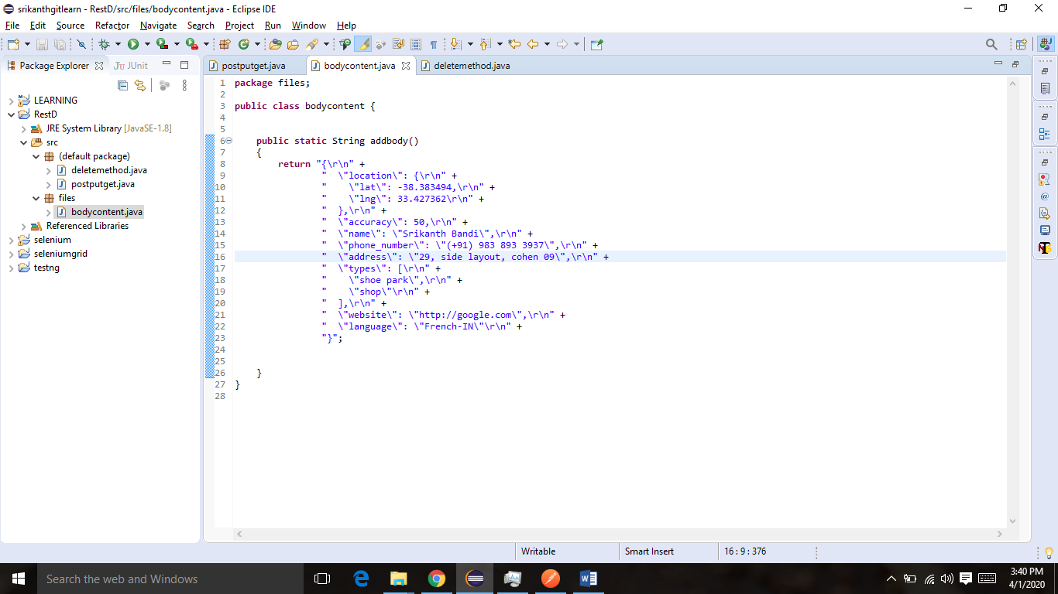

POST/PUT/GET

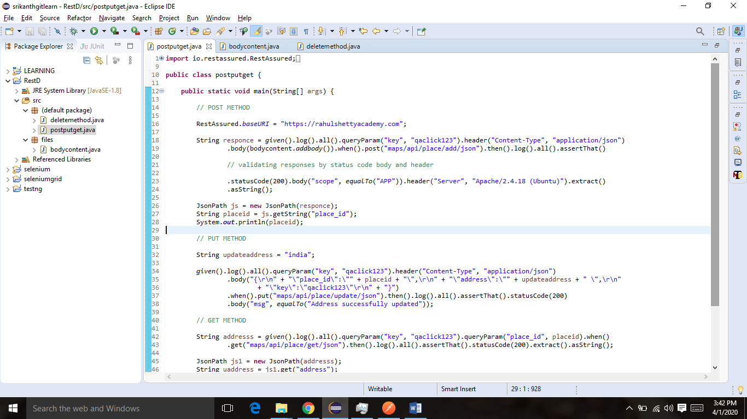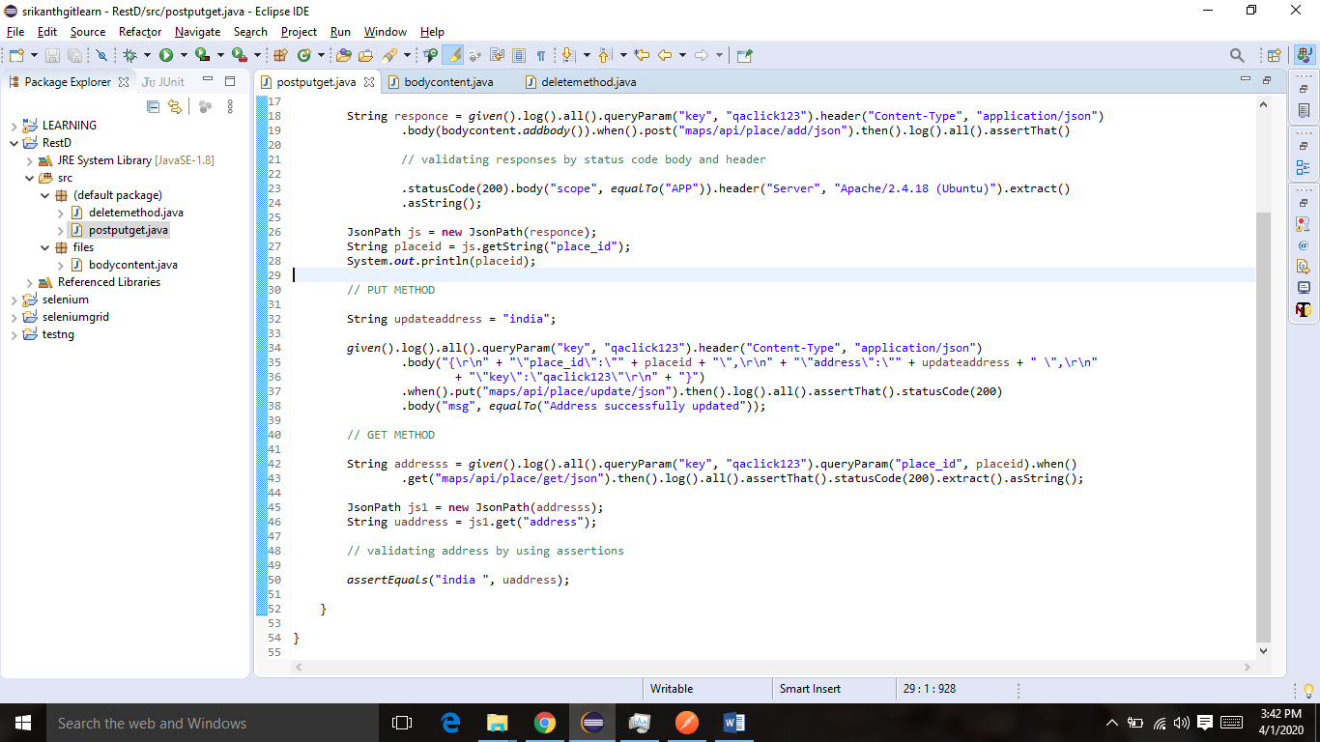

**Output**

Request method: POST

Request URI: https://rahulshettyacademy.com/maps/api/place/add/json?key=qaclick123

Proxy: <none>

Request params: <none>

Query params: key=qaclick123

Form params: <none>

Path params: <none>

Headers: Accept=*/*

Content-Type=application/json; charset=UTF-8

Cookies: <none>

Multiparts: <none>

Body:

{

"location": {

"lat": -38.383494,

"lng": 33.427362

},

"accuracy": 50,

"name": "Srikanth Bandi",

"phone_number": "(+91) 983 893 3937",

"address": "29, side layout, cohen 09",

"types": [

"shoe park",

"shop"

],

"website": "http://google.com",

"language": "French-IN"

}

HTTP/1.1 200 OK

Date: Wed, 01 Apr 2020 10:12:41 GMT

Server: Apache/2.4.18 (Ubuntu)

Access-Control-Allow-Origin: *

Access-Control-Allow-Methods: POST

Access-Control-Max-Age: 3600

Access-Control-Allow-Headers: Content-Type, Access-Control-Allow-Headers, Authorization, X-Requested-With

Content-Length: 194

Keep-Alive: timeout=5, max=100

Connection: Keep-Alive

Content-Type: application/json;charset=UTF-8

{

"status": "OK",

"place_id": "881d3f8902d6ac3ee47494a8f8a7b726",

"scope": "APP",

"reference": "9349c79cb1780375524de1f2e6af8d8c9349c79cb1780375524de1f2e6af8d8c",

"id": "9349c79cb1780375524de1f2e6af8d8c"

}

881d3f8902d6ac3ee47494a8f8a7b726

Request method: PUT

Request URI: https://rahulshettyacademy.com/maps/api/place/update/json?key=qaclick123

Proxy: <none>

Request params: <none>

Query params: key=qaclick123

Form params: <none>

Path params: <none>

Headers: Accept=*/*

Content-Type=application/json; charset=UTF-8

Cookies: <none>

Multiparts: <none>

Body:

{

"place_id": "881d3f8902d6ac3ee47494a8f8a7b726",

"address": "india ",

"key": "qaclick123"

}

HTTP/1.1 200 OK

Date: Wed, 01 Apr 2020 10:12:43 GMT

Server: Apache/2.4.18 (Ubuntu)

Access-Control-Allow-Origin: *

Access-Control-Allow-Methods: POST

Access-Control-Max-Age: 3600

Access-Control-Allow-Headers: Content-Type, Access-Control-Allow-Headers, Authorization, X-Requested-With

Content-Length: 38

Keep-Alive: timeout=5, max=100

Connection: Keep-Alive

Content-Type: application/json;charset=UTF-8

{

"msg": "Address successfully updated"

}

Request method: GET

Request URI: https://rahulshettyacademy.com/maps/api/place/get/json?key=qaclick123&place_id=881d3f8902d6ac3ee47494a8f8a7b726

Proxy: <none>

Request params: <none>

Query params: key=qaclick123

place_id=881d3f8902d6ac3ee47494a8f8a7b726

Form params: <none>

Path params: <none>

Headers: Accept=*/*

Cookies: <none>

Multiparts: <none>

Body: <none>

HTTP/1.1 200 OK

Date: Wed, 01 Apr 2020 10:12:44 GMT

Server: Apache/2.4.18 (Ubuntu)

Access-Control-Allow-Origin: *

Access-Control-Allow-Methods: POST

Access-Control-Max-Age: 3600

Access-Control-Allow-Headers: Content-Type, Access-Control-Allow-Headers, Authorization, X-Requested-With

Content-Length: 237

Keep-Alive: timeout=5, max=100

Connection: Keep-Alive

Content-Type: application/json;charset=UTF-8

{

"location": {

"latitude": "-38.383494",

"longitude": "33.427362"

},

"accuracy": "50",

"name": "Srikanth Bandi",

"phone_number": "(+91) 983 893 3937",

"address": "india ",

"types": "shoe park,shop",

"website": "http://google.com",

"language": "French-IN"

}

**POST/GET/DELETE**

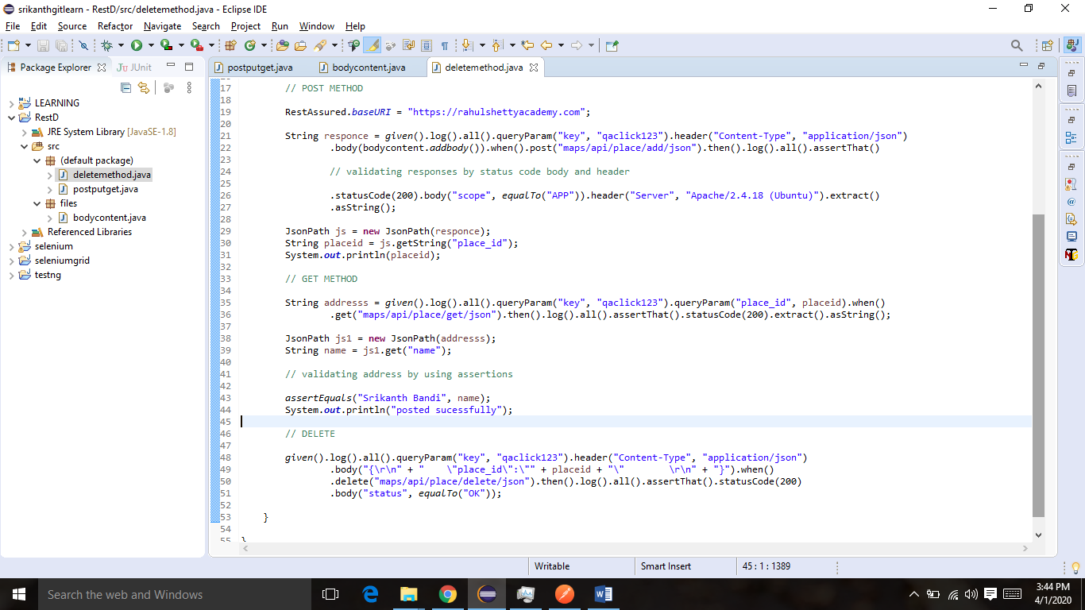

**Output**

Request method: POST

Request URI: https://rahulshettyacademy.com/maps/api/place/add/json?key=qaclick123

Proxy: <none>

Request params: <none>

Query params: key=qaclick123

Form params: <none>

Path params: <none>

Headers: Accept=*/*

Content-Type=application/json; charset=UTF-8

Cookies: <none>

Multiparts: <none>

Body:

{

"location": {

"lat": -38.383494,

"lng": 33.427362

},

"accuracy": 50,

"name": "Srikanth Bandi",

"phone_number": "(+91) 983 893 3937",

"address": "29, side layout, cohen 09",

"types": [

"shoe park",

"shop"

],

"website": "http://google.com",

"language": "French-IN"

}

HTTP/1.1 200 OK

Date: Wed, 01 Apr 2020 10:15:22 GMT

Server: Apache/2.4.18 (Ubuntu)

Access-Control-Allow-Origin: *

Access-Control-Allow-Methods: POST

Access-Control-Max-Age: 3600

Access-Control-Allow-Headers: Content-Type, Access-Control-Allow-Headers, Authorization, X-Requested-With

Content-Length: 194

Keep-Alive: timeout=5, max=100

Connection: Keep-Alive

Content-Type: application/json;charset=UTF-8

{

"status": "OK",

"place_id": "8811513132fa414c321387ce623c391d",

"scope": "APP",

"reference": "d6f88590babe949b970fc1d26ef52e40d6f88590babe949b970fc1d26ef52e40",

"id": "d6f88590babe949b970fc1d26ef52e40"

}

8811513132fa414c321387ce623c391d

Request method: GET

Request URI: https://rahulshettyacademy.com/maps/api/place/get/json?key=qaclick123&place_id=8811513132fa414c321387ce623c391d

Proxy: <none>

Request params: <none>

Query params: key=qaclick123

place_id=8811513132fa414c321387ce623c391d

Form params: <none>

Path params: <none>

Headers: Accept=*/*

Cookies: <none>

Multiparts: <none>

Body: <none>

HTTP/1.1 200 OK

Date: Wed, 01 Apr 2020 10:15:24 GMT

Server: Apache/2.4.18 (Ubuntu)

Access-Control-Allow-Origin: *

Access-Control-Allow-Methods: POST

Access-Control-Max-Age: 3600

Access-Control-Allow-Headers: Content-Type, Access-Control-Allow-Headers, Authorization, X-Requested-With

Content-Length: 256

Keep-Alive: timeout=5, max=100

Connection: Keep-Alive

Content-Type: application/json;charset=UTF-8

{

"location": {

"latitude": "-38.383494",

"longitude": "33.427362"

},

"accuracy": "50",

"name": "Srikanth Bandi",

"phone_number": "(+91) 983 893 3937",

"address": "29, side layout, cohen 09",

"types": "shoe park,shop",

"website": "http://google.com",

"language": "French-IN"

}

posted sucessfully

Request method: DELETE

Request URI: https://rahulshettyacademy.com/maps/api/place/delete/json?key=qaclick123

Proxy: <none>

Request params: <none>

Query params: key=qaclick123

Form params: <none>

Path params: <none>

Headers: Accept=*/*

Content-Type=application/json; charset=UTF-8

Cookies: <none>

Multiparts: <none>

Body:

{

"place_id": "8811513132fa414c321387ce623c391d"

}

HTTP/1.1 200 OK

Date: Wed, 01 Apr 2020 10:15:25 GMT

Server: Apache/2.4.18 (Ubuntu)

Access-Control-Allow-Origin: *

Access-Control-Allow-Methods: POST

Access-Control-Max-Age: 3600

Access-Control-Allow-Headers: Content-Type, Access-Control-Allow-Headers, Authorization, X-Requested-With

Content-Length: 15

Keep-Alive: timeout=5, max=100

Connection: Keep-Alive

Content-Type: application/json;charset=UTF-8

{

"status": "OK"

}